Chapter 21

21.0 Objectives

At the end of this lesson, students should be able to,
- Identify electromotive force (EMF) and DC current.
- Identify the functions of voltmeters and ammeters.
- Calculate the total resistance of series and parallel configurations of resistors.
- Apply Kirchhoff’s rules to analyze voltage and current in complex DC circuits.
- Analyze behavior of RC circuits.
21.1 Introduction
This chapter covers electromotive force, DC current, voltmeters, ammeters, Kirchhoff’s rules, RC circuits and related calculations.
21.2 Resistors
Most circuits have more than one component, called a resistor that limits the flow of charge in the circuit. A measure of this limit on charge flow is called resistance. The simplest combinations of resistors are the series and parallel connections illustrated in Figure 21.1. The total resistance of a combination of resistors depends on both their individual values and how they are connected.
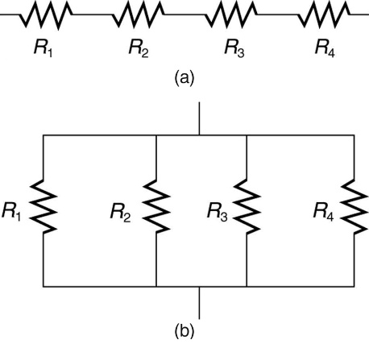
Figure 21.1: (a) A series connection of resistors. (b) A parallel connection of resistors.

2.13 Resistors in Series
When are resistors in series? Resistors are in series whenever the flow of charge, called the current, must flow through devices sequentially. For example, if current flows through a person holding a screwdriver and into the Earth, then R1 in Figure 21.1 (a) could be the resistance of the screwdriver’s shaft, R2 the resistance of its handle, R3 the person’s body resistance, and R4 the resistance of her shoes.
Figure 21.2 shows resistors in series connected to a voltage source. It seems reasonable that the total resistance is the sum of the individual resistances, considering that the current has to pass through each resistor in sequence. (This fact would be an advantage to a person wishing to avoid an electrical shock, who could reduce the current by wearing high-resistance rubber-soled shoes. It could be a disadvantage if one of the resistances were a faulty high-resistance cord to an appliance that would reduce the operating current.)
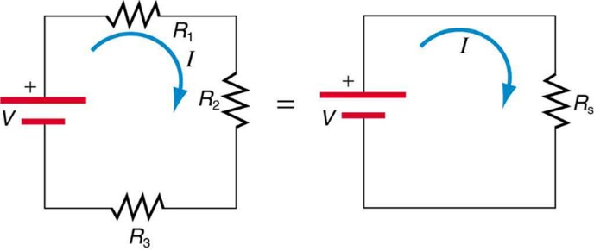
Figure 21.2: Three resistors connected in series to a battery (left) and the equivalent single or series resistance (right).
To verify that resistances in series do indeed add, let us consider the loss of electrical power, called a voltage drop, in each resistor in Figure 21.2.
According to Ohm’s law, the voltage drop, V, across a resistor when a current flows through it is calculated using the equation V=IR, where I equals the current in amps (A) and R is the resistance in ohms (Ω). Another way to think of this is that V is the voltage necessary to make a current I flow through a resistance R.
So the voltage drop across R₁ is V₁ = IR₁, that across R₂ is V₂ = IR₂, and that across R₃ is V₃ = IR₃. The sum of these voltages equals the voltage output of the source; that is,
V = V₁ + V₂ + V₃

This equation is based on the conservation of energy and conservation of charge. Electrical potential energy can be described by the equation PE = qV, where q is the electric charge and V is the voltage. Thus, the energy supplied by the source is qV, while that dissipated by the resistors is
qV₁ + qV₂ +qV₃
These energies must be equal, because there is no other source and no other destination for energy in the circuit. Thus, qV = qV₁ + qV₂ + qV₃. The charge q cancels, yielding V = V₁ + V₂ + V₃, as stated. (Note that the same amount of charge passes through the battery and each resistor in a given amount of time, since there is no capacitance to store charge, there is no place for charge to leak, and charge is conserved.)
Now substituting the values for the individual voltages gives
V = IR₁ + IR₂ + IR₃ = I(R₁+R₂+R₃)
Note that for the equivalent single series resistance Rs, we have
V = IR_{s}
This implies that the total or equivalent series resistance Rs of three resistors is Rs=R1+R2+R3.
This logic is valid in general for any number of resistors in series; thus, the total resistance Rs of a series connection is
R_{s} = R₁ + R₂ + R₃ + ...
as proposed. Since all of the current must pass through each resistor, it experiences the resistance of each, and resistances in series simply add up.
Example - Calculating Resistance, Current, Voltage Drop, and Power Dissipation: Analysis of a Series Circuit
Suppose the voltage output of the battery in Figure 21.2 is 12.0V, and the resistances are R₁ = 1.00Ω, R₂ = 6.00Ω, and R₃ =13.0Ω. (a) What is the total resistance? (b) Find the current. (c) Calculate the voltage drop in each resistor and show these add to equal the voltage output of the source. (d) Calculate the power dissipated by each resistor. (e) Find the power output of the source, and show that it equals the total power dissipated by the resistors.

Strategy and Solution for (a)
The total resistance is simply the sum of the individual resistances, as given by this equation:
R_{s} = R₁ + R₂ + R₃

= 1.00 Ω + 6.00 Ω + 13.0 Ω

= 20.0 Ω

Strategy and Solution for (b)
The current is found using Ohm’s law, V = IR. Entering the value of the applied voltage and the total resistance yields the current for the circuit:
I = V/R_{s} = 12.0V / 20.0Ω = 0.600A

Strategy and Solution for (c)
The voltage — or IR drop — in a resistor is given by Ohm’s law. Entering the current and the value of the first resistance yields
V₁ = IR₁ = (0.600A)(1.0Ω) = 0.600V
Similarly,
V₂ = IR₂ = (0.600A)(6.0Ω) = 3.60V
and
V₃ = IR₃ = (0.600A)(13.0Ω) = 7.80V

Discussion for (c)
The three IR drops add to 12.0 V, as predicted:
V₁ + V₂ + V₃ = (0.600 + 3.60 + 7.80)V =12.0V

Strategy and Solution for (d)
The easiest way to calculate power in watts (W) dissipated by a resistor in a DC circuit is to use Joule’s law, P = IV, where P is electric power. In this case, each resistor has the same full current flowing through it. By substituting Ohm’s law V = IR into Joule’s law, we get the power dissipated by the first resistor as
P₁ = I²R₁ = (0.600A)²(1.00Ω) = 0.360W
Similarly,
P₂ = I²R₂ = (0.600A)²(6.00Ω) = 2.16W
and
P₃ = I²R₃ = (0.600A)²(13.0Ω) = 4.68W

Discussion for (d)
Power can also be calculated using either P = IV or P = V²/R, where V is the voltage drop across the resistor (not the full voltage of the source). The same values will be obtained.

Strategy and Solution for (e)
The easiest way to calculate power output of the source is to use P=IV, where V is the source voltage. This gives,
P = (0.600A)(12.0V) = 7.20W

Discussion for (e)
Note, coincidentally, that the total power dissipated by the resistors is also 7.20 W, the same as the power put out by the source. That is,
P₁ + P₂ + P₃ = (0.360+2.16+4.68) W = 7.20W
Power is energy per unit time (watts), and so conservation of energy requires the power output of the source to be equal to the total power dissipated by the resistors.
Major Features of Resistors in Series
- Series resistances add: Rs=R₁+R₂+R₃+....
- The same current flows through each resistor in series.
- Individual resistors in series do not get the total source voltage, only a divided value.

21.4 Resistors in Parallel
Figure 2.13 shows resistors in parallel, wired to a voltage source. Resistors are in parallel when each resistor is connected directly to the voltage source by connecting wires having negligible resistance. Each resistor thus has the full voltage of the source applied to it.
Each resistor draws the same current it would if it alone were connected to the voltage source (provided the voltage source is not overloaded). For example, an automobile’s headlights, radio, and so on, are wired in parallel, so that they utilize the full voltage of the source and can operate completely independently. The same is true in your house, or any building. (See Figure21.3 (b).)
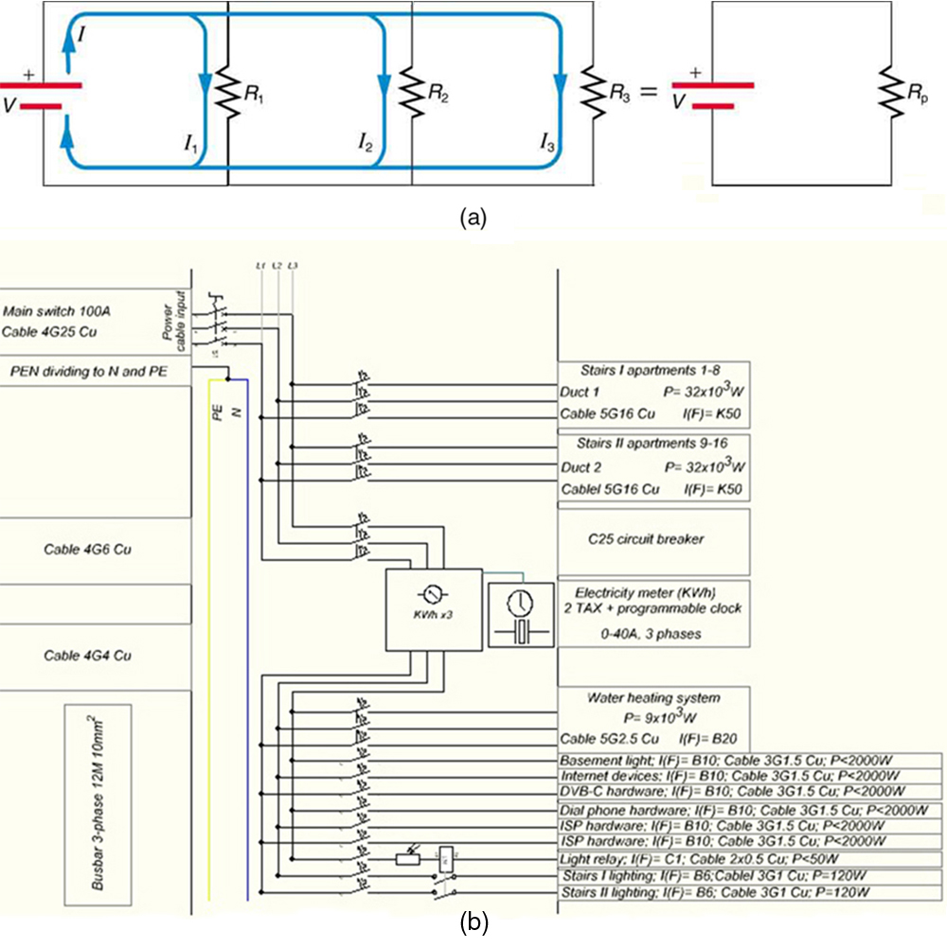
Figure 21.3: (a) Three resistors connected in parallel to a battery and the equivalent single or parallel resistance. (b) Electrical power setup in a house. (credit: Dmitry G, Wikimedia Commons)
To find an expression for the equivalent parallel resistance Rp, let us consider the currents that flow and how they are related to resistance. Since each resistor in the circuit has the full voltage, the currents flowing through the individual resistors are I₁ = V/R₁, I₂ = V/R₂, and I₃ = V/R₃. Conservation of charge implies that the total current I produced by the source is the sum of these currents:
I = I₁ + I₂ + I₃
Substituting the expressions for the individual currents gives
I = V/ R₁ + V/R₂ + V/R₃ = V(1/R₁+1/R₂+1/R₃)
Note that Ohm’s law for the equivalent single resistance gives,
I = V/R_{p} = V(1/Rp)
The terms inside the parentheses in the last two equations must be equal. Generalizing to any number of resistors, the total resistance Rp of a parallel connection is related to the individual resistances by
1/R_{p} = 1/R₁ + 1/R₂+1/R₃ +....
This relationship results in a total resistance R_{p} that is less than the smallest of the individual resistances. When resistors are connected in parallel, more current flows from the source than would flow for any of them individually, and so the total resistance is lower.

Major Features of Resistors in Parallel
- Parallel resistance is found from 1/R_{p} = 1/R₁ + 1/R₂ +1/R₃ + ..., and it is smaller than any individual resistance in the combination.
- Each resistor in parallel has the same full voltage of the source applied to it. (Power distribution systems most often use parallel connections to supply the myriad devices served with the same voltage and to allow them to operate independently.)
- Parallel resistors do not each get the total current; they divide it.

21. 5 Combinations of Series and Parallel
More complex connections of resistors are sometimes just combinations of series and parallel. These are commonly encountered, especially when wire resistance is considered. In that case, wire resistance is in series with other resistances that are in parallel.
Combinations of series and parallel can be reduced to a single equivalent resistance using the technique illustrated in Figure 21.4. Various parts are identified as either series or parallel, reduced to their equivalents, and further reduced until a single resistance is left. The process is more time consuming than difficult.
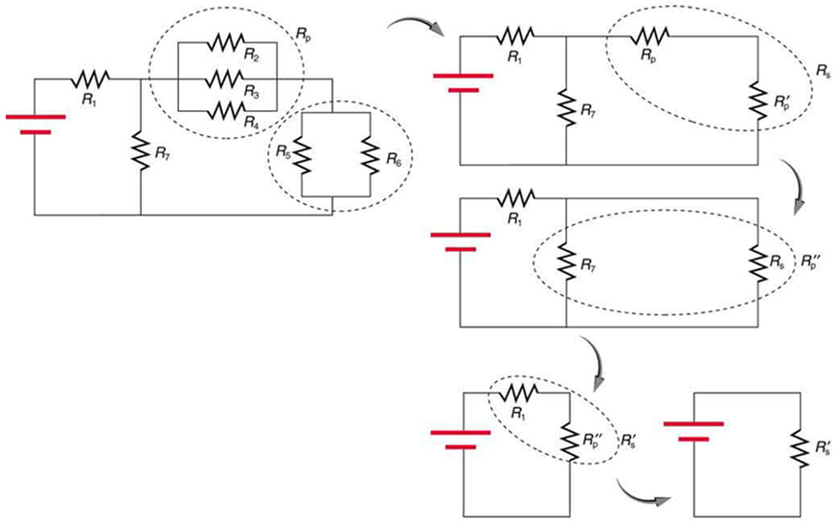
Figure 21.4: This combination of seven resistors has both series and parallel parts. Each is identified and reduced to an equivalent resistance, and these are further reduced until a single equivalent resistance is reached.
The simplest combination of series and parallel resistance, shown in Figure 21.5, is also the most instructive, since it is found in many applications. For example, R1 could be the resistance of wires from a car battery to its electrical devices, which are in parallel. R2 and R3 could be the starter motor and a passenger compartment light. We have previously assumed that wire resistance is negligible, but, when it is not, it has important effects, as the next example indicates.
Example - Calculating Resistance, IR Drop, Current, and Power Dissipation: Combining Series and Parallel Circuits
Figure 21.5 shows the resistors from the previous two examples wired in a different way—a combination of series and parallel. We can consider R1 to be the resistance of wires leading to R₂ and R₃. (a) Find the total resistance. (b) What is the IR drop in R₁? (c) Find the current I₂ through R₂. (d) What power is dissipated by R₂?
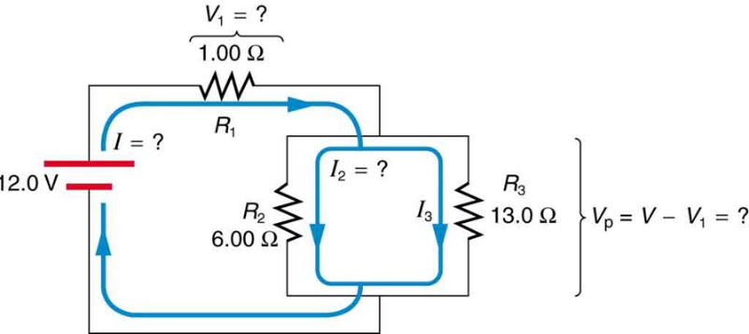
Figure 21.5: These three resistors are connected to a voltage source so that R₂ and R₃ are in parallel with each another and that combination is in series with R₁.

Strategy and Solution for (a)
To find the total resistance, we note that R₂ and R₃ are in parallel and their combination R_{p} is in series with R₁. Thus, the total (equivalent) resistance of this combination is
R_{tot} = R₁ + R_{p}
First, we find Rp using the equation for resistors in parallel and entering known values:
1/R_{p} = 1/R₂ + 1/R₃ = 1/6.00Ω + 1/13.0Ω = 0.2436/Ω.
Inverting gives
R_{p} = 1/ 0.2436Ω = 4.11Ω
So, the total resistance is
R_{tot} = R₁+R_{p} = 1.00Ω + 4.11Ω = 5.11Ω

Discussion for (a)
The total resistance of this combination is intermediate between the pure series and pure parallel values (20.0 Ω and 0.804 Ω, respectively) found for the same resistors in the two previous examples.

Strategy and Solution for (b)
To find the IR drop in R1, we note that the full current I flows through R1. Thus its IR drop is
V₁ = IR₁
We must find I before we can calculate V1. The total current I is found using Ohm’s law for the circuit. That is,
I = V/R_{tot} = 12.0V / 5.11Ω = 2.35A
Entering this into the expression above, we get
V₁ = IR₁= (2.35A)(1.00Ω) = 2.35V

Discussion for (b)
The voltage applied to R₂ and R₃ is less than the total voltage by an amount V₁. When wire resistance is large, it can significantly affect the operation of the devices represented by R₂ and R₃.

Strategy and Solution for (c)
To find the current through R₂, we must first find the voltage applied to it. We call this voltage V_{p}, because it is applied to a parallel combination of resistors. The voltage applied to both R₂ and R₃ is reduced by the amount V₁, and so it is,
V_{p} = V − V₁ = 12.0V − 2.35V = 9.65V
Now the current I₂ through resistance R₂ is found using Ohm’s law:
I₂ = V_{p}R₂ = 9.65 V/6.00Ω = 1.61A

Discussion for (c)
The current is less than the 2.00 A that flowed through R₂ when it was connected in parallel to the battery in the previous parallel circuit example.

Strategy and Solution for (d)
The power dissipated by R₂ is given by
P₂ = (I²)²R₂ = (1.61A)²(6.00Ω) = 15.5W

Discussion for (d)
The power is less than the 24.0 W this resistor dissipated when connected in parallel to the 12.0-V source.
21.6 Electromotive Force
You can think of many different types of voltage sources. Batteries themselves come in many varieties. There are many types of mechanical/electrical generators, driven by many different energy sources, ranging from nuclear to wind. Solar cells create voltages directly from light, while thermoelectric devices create voltage from temperature differences.
A few voltage sources are shown in Figure 21.6. All such devices create a potential difference and can supply current if connected to a resistance. On the small scale, the potential difference creates an electric field that exerts force on charges, causing current. We thus use the name electromotive force, abbreviated emf.
Emf is not a force at all; it is a special type of potential difference. To be precise, the electromotive force (emf) is the potential difference of a source when no current is flowing. Units of emf are volts.
Figure 21.6: A variety of voltage sources (clockwise from top left): the Brazos Wind Farm in Fluvanna, Texas (credit: Leaflet, Wikimedia Commons); the Krasnoyarsk Dam in Russia (credit: Alex Polezhaev); a solar farm (credit: U.S. Department of Energy); and a group of nickel metal hydride batteries (credit: Tiaa Monto). The voltage output of each depends on its construction and load, and equals emf only if there is no load.
Electromotive force is directly related to the source of potential difference, such as the particular combination of chemicals in a battery. However, emf differs from the voltage output of the device when current flows. The voltage across the terminals of a battery, for example, is less than the emf when the battery supplies current, and it declines further as the battery is depleted or loaded down. However, if the device’s output voltage can be measured without drawing current, then output voltage will equal emf (even for a very depleted battery).
21.7 Internal Resistance
A 12-V truck battery is physically larger, contains more charge and energy, and can deliver a larger current than a 12-V motorcycle battery. Both are lead-acid batteries with identical emf, but, because of its size, the truck battery has a smaller internal resistance r. Internal resistance is the inherent resistance to the flow of current within the source itself.
Figure 21.7 is a schematic representation of the two fundamental parts of any voltage source. The emf (represented by a script E in the figure) and internal resistance r are in series. The smaller the internal resistance for a given emf, the more current and the more power the source can supply.
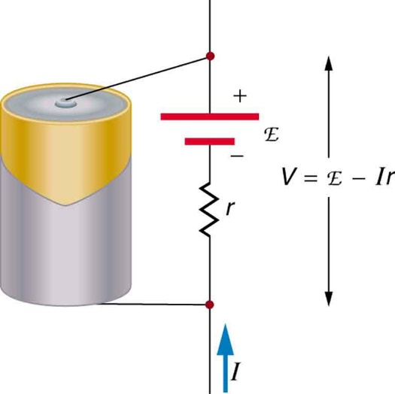
Figure 21.7: Any voltage source (in this case, a carbon-zinc dry cell) has an emf related to its source of potential difference, and an internal resistance r related to its construction. (Note that the script E stands for emf.). Also shown are the output terminals across which the terminal voltage V is measured. Since V=emf−Ir, terminal voltage equals emf only if there is no current flowing.
The internal resistance r can behave in complex ways. As noted, r increases as a battery is depleted. But internal resistance may also depend on the magnitude and direction of the current through a voltage source, its temperature, and even its history. The internal resistance of rechargeable nickel-cadmium cells, for example, depends on how many times and how deeply they have been depleted.
Various types of batteries are available, with emfs determined by the combination of chemicals involved. We can view this as a molecular reaction (what much of chemistry is about) that separates charge.
The lead-acid battery used in cars and other vehicles is one of the most common types. A single cell (one of six) of this battery is seen in Figure 21.8. The cathode (positive) terminal of the cell is connected to a lead oxide plate, while the anode (negative) terminal is connected to a lead plate. Both plates are immersed in sulfuric acid, the electrolyte for the system.
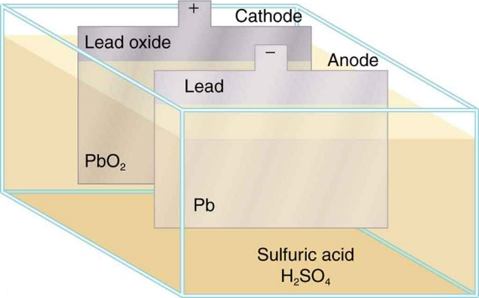
Figure 21.8: Artist’s conception of a lead-acid cell. Chemical reactions in a lead-acid cell separate charge, sending negative charge to the anode, which is connected to the lead plates. The lead oxide plates are connected to the positive or cathode terminal of the cell. Sulfuric acid conducts the charge as well as participating in the chemical reaction.
In the case of a lead-acid battery, an energy of 2 eV is given to each electron sent to the anode. Voltage is defined as the electrical potential energy divided by charge: V =PE/q. An electron volt is the energy given to a single electron by a voltage of 1 V. So, the voltage here is 2 V, since 2 eV is given to each electron. It is the energy produced in each molecular reaction that produces the voltage. A different reaction produces a different energy and, hence, a different voltage.
21.8 Terminal Voltage
The voltage output of a device is measured across its terminals and, thus, is called its terminal voltage V. Terminal voltage is given by
V = emf − Ir

where r is the internal resistance, and I is the current flowing at the time of the measurement.
I is positive if current flows away from the positive terminal, as shown in Figure 21.7. You can see that the larger the current, the smaller the terminal voltage. And it is likewise true that the larger the internal resistance, the smaller the terminal voltage.
Suppose a load resistance R_{load} is connected to a voltage source, as in Figure 21.9. Since the resistances are in series, the total resistance in the circuit is R_{load}+r. Thus, the current is given by Ohm’s law to be
I = emf / (R_{load}+r)

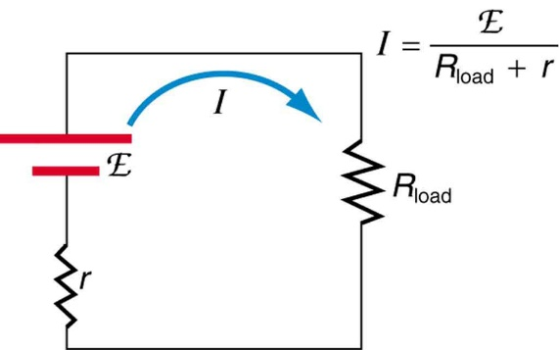
Figure 21.9: Schematic of a voltage source and its load R_{load}. Since the internal resistance r is in series with the load, it can significantly affect the terminal voltage and current delivered to the load. (Note that the script E stands for emf.)
We see from this expression that the smaller the internal resistance r, the greater the current the voltage source supplies to its load Rload. As batteries are depleted, r increases. If r becomes a significant fraction of the load resistance, then the current is significantly reduced, as the following example illustrates.

Example - Calculating Terminal Voltage, Power Dissipation, Current, and Resistance: Terminal Voltage and Load
A certain battery has a 12.0-V emf and an internal resistance of 0.100Ω. (a) Calculate its terminal voltage when connected to a 10.0-Ω load. (b) What is the terminal voltage when connected to a 0.500-Ω load? (c) What power does the 0.500-Ω load dissipate? (d) If the internal resistance grows to 0.500Ω, find the current, terminal voltage, and power dissipated by a 0.500-Ω load.
Strategy
The analysis above gave an expression for current when internal resistance is taken into account. Once the current is found, the terminal voltage can be calculated using the equation V = emf − Ir. Once current is found, the power dissipated by a resistor can also be found.

Solution for (a)
Entering the given values for the emf, load resistance, and internal resistance into the expression above yields
I = emf / R_{load} +r = 12.0V/ 10.1Ω =1.188A

Enter the known values into the equation V = emf − Ir to get the terminal voltage:
V = emf – Ir = 12.0 V − (1.188 A)(0.100 Ω)

= 11.9 V

Discussion for (a)
The terminal voltage here is only slightly lower than the emf, implying that 10.0Ω is a light load for this particular battery.

Solution for (b)
Similarly, with R_{load} = 0.500Ω, the current is
I = emf / R_{load} +r = 12.0V / 0.600Ω =20.0A
The terminal voltage is now
V = emf − Ir = 12.0 V − (20.0 A)(0.100 Ω)

= 10.0 V

Discussion for (b)
This terminal voltage exhibits a more significant reduction compared with emf, implying 0.500Ω is a heavy load for this battery.

Solution for (c)
The power dissipated by the 0.500 - Ω load can be found using the formula P = I²R. Entering the known values gives
P_{load} = I²R_{load} = (20.0A)²(0.500 Ω) = 2.00×10²W

Discussion for (c)
Note that this power can also be obtained using the expressions V²R or IV, where V is the terminal voltage (10.0 V in this case).

Solution for (d)
Here the internal resistance has increased, perhaps due to the depletion of the battery, to the point where it is as great as the load resistance. As before, we first find the current by entering the known values into the expression, yielding,
I = emf / R_{load} + r = 12.0V / 1.00Ω = 12.0A

Now the terminal voltage is
V = emf – Ir = 12.0 V − (12.0 A)(0.500 Ω)

= 6.00 V

and the power dissipated by the load is
P_{load} = I²R_{load} = (12.0 A)²(0.500Ω) = 72.0W

Discussion for (d)
We see that the increased internal resistance has significantly decreased terminal voltage, current, and power delivered to a load.
Some batteries can be recharged by passing a current through them in the direction opposite to the current they supply to a resistance. This is done routinely in cars and batteries for small electrical appliances and electronic devices, and is represented pictorially in Figure 21.20. The voltage output of the battery charger must be greater than the emf of the battery to reverse current through it. This will cause the terminal voltage of the battery to be greater than the emf, since V=emf−Ir, and I is now negative.
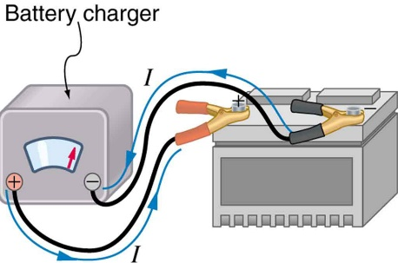
Figure 21.10: A car battery charger reverses the normal direction of current through a battery, reversing its chemical reaction and replenishing its chemical potential.

21.9 Multiple Voltage Sources
There are two voltage sources when a battery charger is used. Voltage sources connected in series are relatively simple. When voltage sources are in series, their internal resistances add and their emfs add algebraically. (See Figure 21.11.) Series connections of voltage sources are common—for example, in flashlights, toys, and other appliances. Usually, the cells are in series in order to produce a larger total emf.
But if the cells oppose one another, such as when one is put into an appliance backward, the total emf is less, since it is the algebraic sum of the individual emfs.
A battery is a multiple connection of voltaic cells, as shown in Figure 21.12. The disadvantage of series connections of cells is that their internal resistances add. One of the authors once owned a 1957 MGA that had two 6-V batteries in series, rather than a single 12-V battery. This arrangement produced a large internal resistance that caused him many problems in starting the engine.
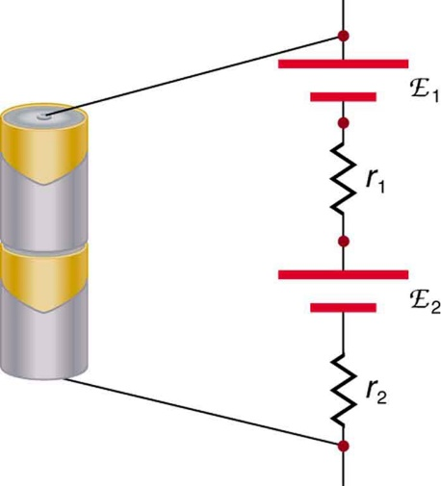
Figure 21.11: A series connection of two voltage sources. The emfs (each labeled with a script E) and internal resistances add, giving a total emf of emf1+emf2 and a total internal resistance of r1+r2.

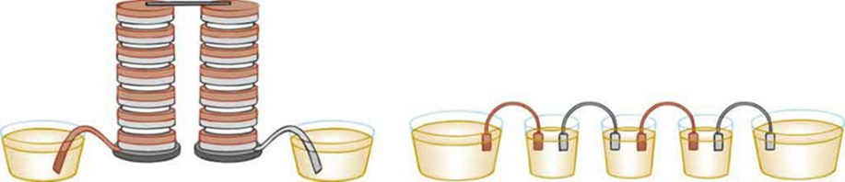
Figure 21.12: Batteries are multiple connections of individual cells, as shown in this modern rendition of an old print. Single cells, such as AA or C cells, are commonly called batteries, although this is technically incorrect.
If the series connection of two voltage sources is made into a complete circuit with the emfs in opposition, then a current of magnitude I = (emf₁ – emf₂) / (r₁+r₂) flows. See Figure 21.13, for example, which shows a circuit exactly analogous to the battery charger discussed above. If two voltage sources in series with emfs in the same sense are connected to a load R_{load}, as in Figure 21.14, then I = (emf₁+emf₂) / (r₁+r₂+R_{load}) flows.
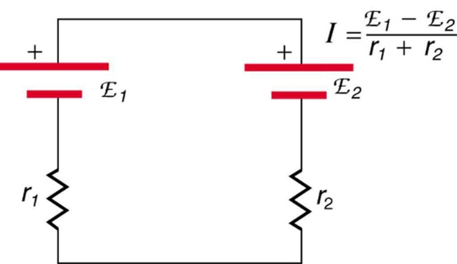
Figure 21.13: These two voltage sources are connected in series with their emfs in opposition. Current flows in the direction of the greater emf and is limited to I = (emf₁ – emf₂) / (r₁+r₂) by the sum of the internal resistances. (Note that each emf is represented by script E in the figure.) A battery charger connected to a battery is an example of such a connection. The charger must have a larger emf than the battery to reverse current through it.
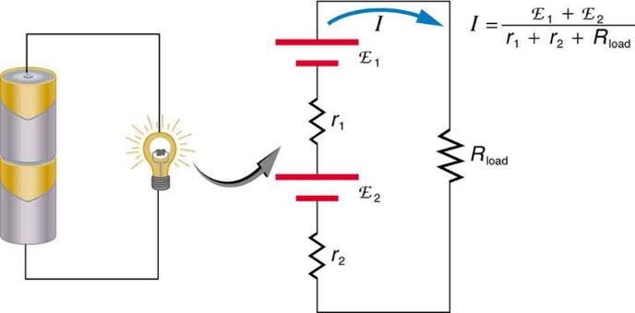
Figure 21.14: This schematic represents a flashlight with two cells (voltage sources) and a single bulb (load resistance) in series. The current that flows is I = (emf₁+emf₂) / (r₁+r₂+R_{load}). (Note that each emf is represented by script E in the figure.)
Figure 21.15 shows two voltage sources with identical emfs in parallel and connected to a load resistance. In this simple case, the total emf is the same as the individual emfs. But the total internal resistance is reduced, since the internal resistances are in parallel. The parallel connection thus can produce a larger current.
Here, I = emf / (r_{tot}+R_{load}) flows through the load, and rtot is less than those of the individual batteries. For example, some diesel-powered cars use two 12-V batteries in parallel; they produce a total emf of 12 V but can deliver the larger current needed to start a diesel engine.
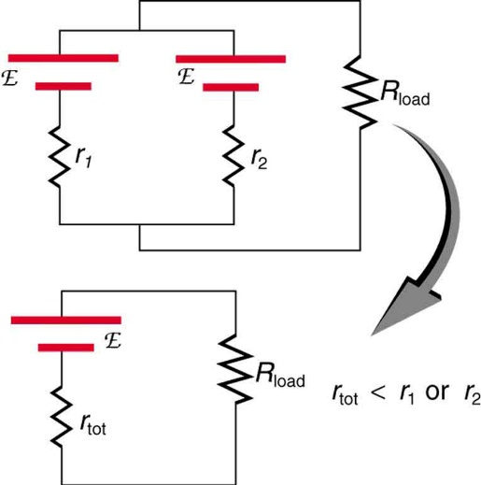
Figure 21.15: Two voltage sources with identical emfs (each labeled by script E) connected in parallel produce the same emf but have a smaller total internal resistance than the individual sources. Parallel combinations are often used to deliver more current. Here I=emf(rtot+Rload) flows through the load.

21. 10 Kirchhoff’s Rules
Many complex circuits, such as the one in Figure 21.16, cannot be analyzed with the series-parallel techniques developed in Resistors in Series and Parallel and Electromotive Force: Terminal Voltage. There are, however, two circuit analysis rules that can be used to analyze any circuit, simple or complex. These rules are special cases of the laws of conservation of charge and conservation of energy. The rules are known as Kirchhoff’s rules, after their inventor Gustav Kirchhoff (1824–1887).
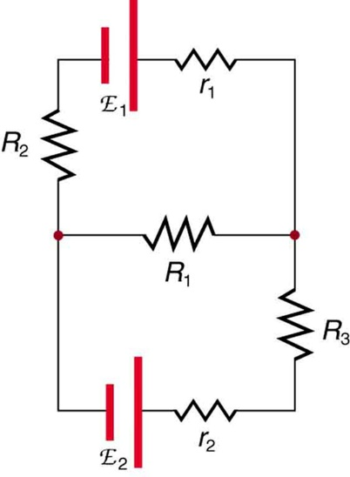
Figure 21.16: This circuit cannot be reduced to a combination of series and parallel connections. Kirchhoff’s rules, special applications of the laws of conservation of charge and energy, can be used to analyze it. (Note: The script E in the figure represents electromotive force, emf.)

Kirchhoff’s Rules
- Kirchhoff’s first rule—the junction rule. The sum of all currents entering a junction must equal the sum of all currents leaving the junction.
- Kirchhoff’s second rule—the loop rule. The algebraic sum of changes in potential around any closed circuit path (loop) must be zero.
Explanations of the two rules will now be given, followed by problem-solving hints for applying Kirchhoff’s rules, and a worked example that uses them.

Kirchhoff’s First Rule
Kirchhoff’s first rule (the junction rule) is an application of the conservation of charge to a junction; it is illustrated in Figure 21.17. Current is the flow of charge, and charge is conserved; thus, whatever charge flows into the junction must flow out. Kirchhoff’s first rule requires that I₁ = I₂ + I₃ (see figure). Equations like this can and will be used to analyze circuits and to solve circuit problems.
Kirchhoff’s rules for circuit analysis are applications of conservation laws to circuits. The first rule is the application of conservation of charge, while the second rule is the application of conservation of energy. Conservation laws, even used in a specific application, such as circuit analysis, are so basic as to form the foundation of that application.
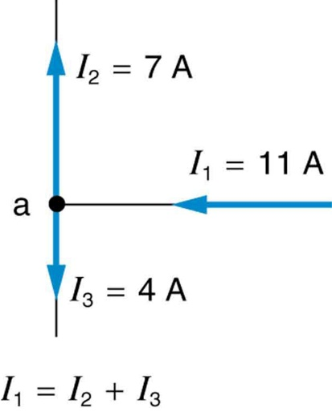
Figure 21.17: The junction rule. The diagram shows an example of Kirchhoff’s first rule where the sum of the currents into a junction equals the sum of the currents out of a junction. In this case, the current going into the junction splits and comes out as two currents, so that I₁ = I₂ + I₃. Here I₁ must be 11 A, since I₂ is 7 A and I₃ is 4 A.

Kirchhoff’s Second Rule
Kirchhoff’s second rule (the loop rule) is an application of conservation of energy. The loop rule is stated in terms of potential, V, rather than potential energy, but the two are related since PEelec=qV. Recall that emf is the potential difference of a source when no current is flowing. In a closed loop, whatever energy is supplied by emf must be transferred into other forms by devices in the loop, since there are no other ways in which energy can be transferred into or out of the circuit. Figure 21.18 illustrates the changes in potential in a simple series circuit loop.
Kirchhoff’s second rule requires emf – Ir − IR₁ − IR₂ = 0. Rearranged, this is emf = Ir + IR₁ + IR₂, which means the emf equals the sum of the IR (voltage) drops in the loop.
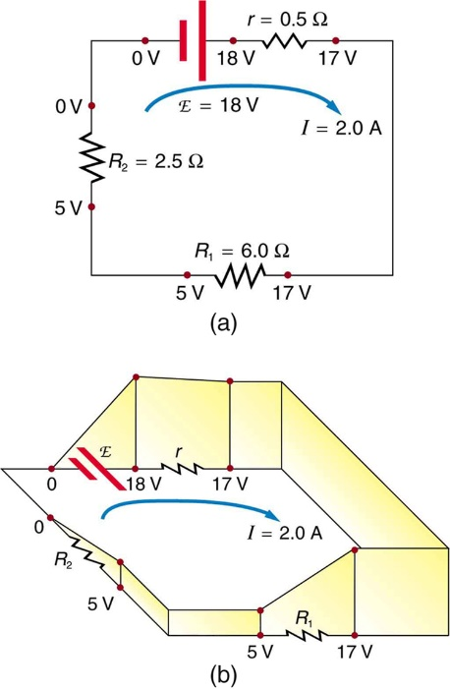
Figure 21.18: The loop rule. An example of Kirchhoff’s second rule where the sum of the changes in potential around a closed loop must be zero. (a) In this standard schematic of a simple series circuit, the emf supplies 18 V, which is reduced to zero by the resistances, with 1 V across the internal resistance, and 12 V and 5 V across the two load resistances, for a total of 18 V. (b) This perspective view represents the potential as something like a roller coaster, where charge is raised in potential by the emf and lowered by the resistances. (Note that the script E stands for emf.)

Applying Kirchhoff’s Rules
By applying Kirchhoff’s rules, we generate equations that allow us to find the unknowns in circuits. The unknowns may be currents, emfs, or resistances. Each time a rule is applied, an equation is produced. If there are as many independent equations as unknowns, then the problem can be solved. There are two decisions you must make when applying Kirchhoff’s rules. These decisions determine the signs of various quantities in the equations you obtain from applying the rules.
- When applying Kirchhoff’s first rule, the junction rule, you must label the current in each branch and decide in what direction it is going. For example, in Figures 21.16, 21.17, and 21.18, currents are labeled I₁, I₂, I₃, and I, and arrows indicate their directions. There is no risk here, for if you choose the wrong direction, the current will be of the correct magnitude but negative.
- When applying Kirchhoff’s second rule, the loop rule, you must identify a closed loop and decide in which direction to go around it, clockwise or counterclockwise. For example, in Figure 21.18 the loop was traversed in the same direction as the current (clockwise). Again, there is no risk; going around the circuit in the opposite direction reverses the sign of every term in the equation, which is like multiplying both sides of the equation by –1.
Figure 21.19 and the following points will help you get the plus or minus signs right when applying the loop rule. Note that the resistors and emfs are traversed by going from a to b. In many circuits, it will be necessary to construct more than one loop. In traversing each loop, one needs to be consistent for the sign of the change in potential.
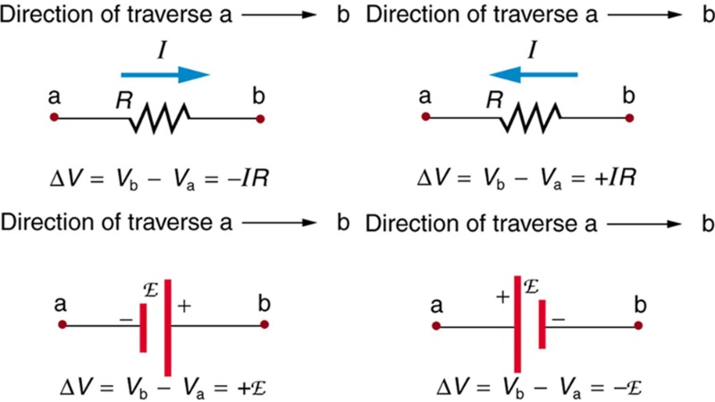
Figure 21.19: Each of these resistors and voltage sources is traversed from a to b. The potential changes are shown beneath each element and are explained in the text. (Note that the script E stands for emf.)
- When a resistor is traversed in the same direction as the current, the change in potential is −IR. (See Figure 21.19.)
- When a resistor is traversed in the direction opposite to the current, the change in potential is +IR. (See Figure 21.19.)
- When an emf is traversed from – to + (the same direction it moves positive charge), the change in potential is +emf. (See Figure 21.19.)
- When an emf is traversed from + to – (opposite to the direction it moves positive charge), the change in potential is −emf. (See Figure 21.19.)

Watch the following video on Kirchhoff’s Rule: https://www.youtube.com/watch?v=0gRtVz4XrZM

Problem-Solving Strategies for Kirchhoff’s Rules
- Make certain there is a clear circuit diagram on which you can label all known and unknown resistances, emfs, and currents. If a current is unknown, you must assign it a direction. This is necessary for determining the signs of potential changes. If you assign the direction incorrectly, the current will be found to have a negative value—no harm done.
- Apply the junction rule to any junction in the circuit. Each time the junction rule is applied, you should get an equation with a current that does not appear in a previous application—if not, then the equation is redundant.
- Apply the loop rule to as many loops as needed to solve for the unknowns in the problem. (There must be as many independent equations as unknowns.) To apply the loop rule, you must choose a direction to go around the loop. Then carefully and consistently determine the signs of the potential changes for each element using the four bulleted points discussed above in conjunction with Figure 21.19.
- Solve the simultaneous equations for the unknowns. This may involve many algebraic steps, requiring careful checking and rechecking.
- Check to see whether the answers are reasonable and consistent. The numbers should be of the correct order of magnitude, neither exceedingly large nor vanishingly small. The signs should be reasonable—for example, no resistance should be negative. Check to see that the values obtained satisfy the various equations obtained from applying the rules. The currents should satisfy the junction rule, for example.

21.11 Instruments
Voltmeters measure voltage, whereas ammeters measure current. Some of the meters in automobile dashboards, digital cameras, cell phones, and tuner-amplifiers are voltmeters or ammeters. (See Figure 21.26.) The internal construction of the simplest of these meters and how they are connected to the system they monitor give further insight into applications of series and parallel connections.
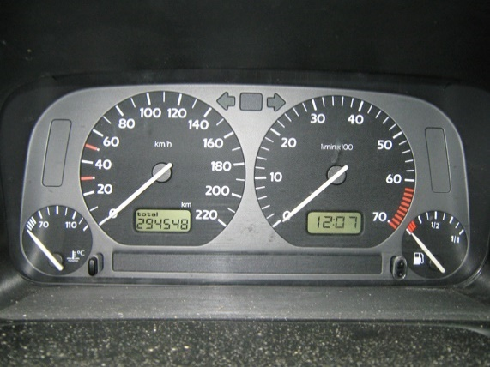
Figure 21.20: The fuel and temperature gauges (far right and far left, respectively) in this 1996 Volkswagen are voltmeters that register the voltage output of “sender” units, which are hopefully proportional to the amount of gasoline in the tank and the engine temperature. (credit: Christian Giersing)
Voltmeters are connected in parallel with whatever device’s voltage is to be measured. A parallel connection is used because objects in parallel experience the same potential difference. (See Figure 21.21, where the voltmeter is represented by the symbol V.)
Ammeters are connected in series with whatever device’s current is to be measured. A series connection is used because objects in series have the same current passing through them. (See Figure 21.22, where the ammeter is represented by the symbol A.)
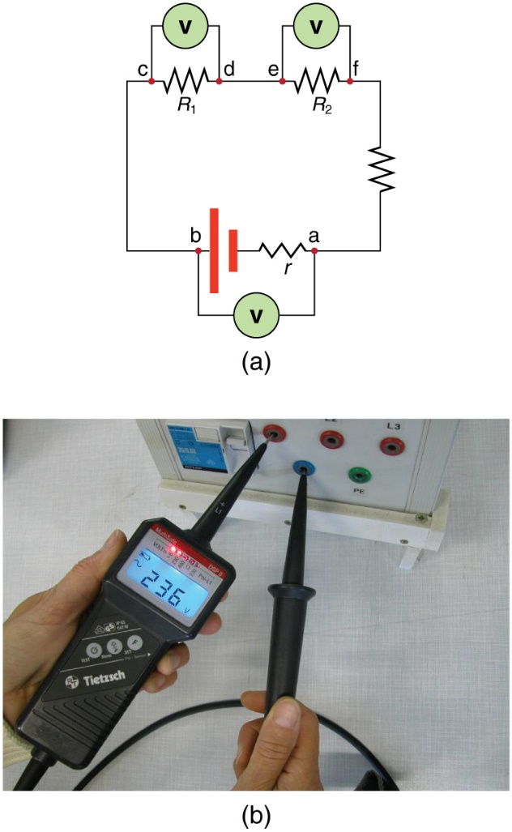
Figure 21.21: (a) To measure potential differences in this series circuit, the voltmeter (V) is placed in parallel with the voltage source or either of the resistors. Note that terminal voltage is measured between points a and b. It is not possible to connect the voltmeter directly across the emf without including its internal resistance, r. (b) A digital voltmeter in use. (credit: Messtechniker, Wikimedia Commons)
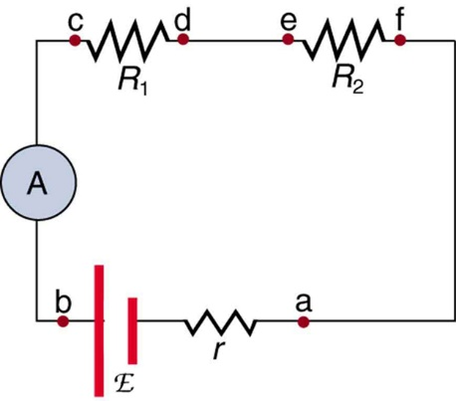
Figure 21.22: An ammeter (A) is placed in series to measure current. All of the current in this circuit flows through the meter. The ammeter would have the same reading if located between points d and e or between points f and a as it does in the position shown. (Note that the script capital E stands for emf, and r stands for the internal resistance of the source of potential difference.)

Analog Meters: Galvanometers
Analog meters have a needle that swivels to point at numbers on a scale, as opposed to digital meters, which have numerical readouts similar to a hand-held calculator. The heart of most analog meters is a device called a galvanometer, denoted by G. Current flow through a galvanometer, IG, produces a proportional needle deflection. (This deflection is due to the force of a magnetic field upon a current-carrying wire.)
The two crucial characteristics of a given galvanometer are its resistance and current sensitivity. Current sensitivity is the current that gives a full-scale deflection of the galvanometer’s needle, the maximum current that the instrument can measure. For example, a galvanometer with a current sensitivity of 50 μA has a maximum deflection of its needle when 50 μA flows through it, reads half-scale when 25 μA flows through it, and so on.
If such a galvanometer has a 25-Ω resistance, then a voltage of only V = IR = (50 μA)(25 Ω) = 1.25 mV produces a full-scale reading. By connecting resistors to this galvanometer in different ways, you can use it as either a voltmeter or ammeter that can measure a broad range of voltages or currents.

Galvanometer as Voltmeter
Figure 21.23 shows how a galvanometer can be used as a voltmeter by connecting it in series with a large resistance, R. The value of the resistance R is determined by the maximum voltage to be measured. Suppose you want 10 V to produce a full-scale deflection of a voltmeter containing a 25-Ω galvanometer with a 50-μA sensitivity. Then 10 V applied to the meter must produce a current of 50 μA. The total resistance must be
R_{tot} = R + r = V/I = 10V/50 μA = 200kΩ, or

R = R_{tot} − r = 200 kΩ − 25Ω ≈ 200kΩ.

(R is so large that the galvanometer resistance, r, is nearly negligible.) Note that 5 V applied to this voltmeter produces a half-scale deflection by producing a 25-μA current through the meter, and so the voltmeter’s reading is proportional to voltage as desired.
This voltmeter would not be useful for voltages less than about half a volt, because the meter deflection would be small and difficult to read accurately. For other voltage ranges, other resistances are placed in series with the galvanometer. Many meters have a choice of scales. That choice involves switching an appropriate resistance into series with the galvanometer.
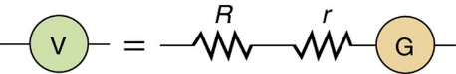
Figure 21.23: A large resistance R placed in series with a galvanometer G produces a voltmeter, the full-scale deflection of which depends on the choice of R. The larger the voltage to be measured, the larger R must be. (Note that r represents the internal resistance of the galvanometer.)
Galvanometer as Ammeter
The same galvanometer can also be made into an ammeter by placing it in parallel with a small resistance R, often called the shunt resistance, as shown in Figure 21.24. Since the shunt resistance is small, most of the current passes through it, allowing an ammeter to measure currents much greater than those producing a full-scale deflection of the galvanometer.
Suppose, for example, an ammeter is needed that gives a full-scale deflection for 1.0 A, and contains the same 25-Ω galvanometer with its 50-μA sensitivity. Since R and r are in parallel, the voltage across them is the same.
These IR drops are I R =I_{G}r so that IR = I_{G} /I = R/r. Solving for R, and noting that I_{G} is 50 μA and I is 0.999950 A, we have
R = r (I_{G}/I) = (25Ω) (50 μA/0.999950 A) = 1.25×10⁻³Ω.

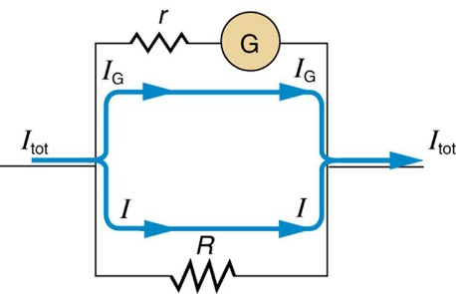
Figure 21.24: A small shunt resistance R placed in parallel with a galvanometer G produces an ammeter, the full-scale deflection of which depends on the choice of R. The larger the current to be measured, the smaller R must be. Most of the current (I) flowing through the meter is shunted through R to protect the galvanometer. (Note that r represents the internal resistance of the galvanometer.) Ammeters may also have multiple scales for greater flexibility in application. The various scales are achieved by switching various shunt resistances in parallel with the galvanometer—the greater the maximum current to be measured, the smaller the shunt resistance must be.
Standard measurements of voltage and current alter the circuit being measured, introducing uncertainties in the measurements. Voltmeters draw some extra current, whereas ammeters reduce current flow. Null measurements balance voltages so that there is no current flowing through the measuring device and, therefore, no alteration of the circuit being measured.
Null measurements are generally more accurate but are also more complex than the use of standard voltmeters and ammeters, and they still have limits to their precision. In this module, we shall consider a few specific types of null measurements, because they are common and interesting, and they further illuminate principles of electric circuits.

The Potentiometer
Suppose you wish to measure the emf of a battery. Consider what happens if you connect the battery directly to a standard voltmeter as shown in Figure 21.25. (Once we note the problems with this measurement, we will examine a null measurement that improves accuracy.) As discussed before, the actual quantity measured is the terminal voltage V, which is related to the emf of the battery by V = emf − Ir, where I is the current that flows and r is the internal resistance of the battery.
The emf could be accurately calculated if r were very accurately known, but it is usually not. If the current I could be made zero, then V = emf, and so emf could be directly measured. However, standard voltmeters need a current to operate; thus, another technique is needed.
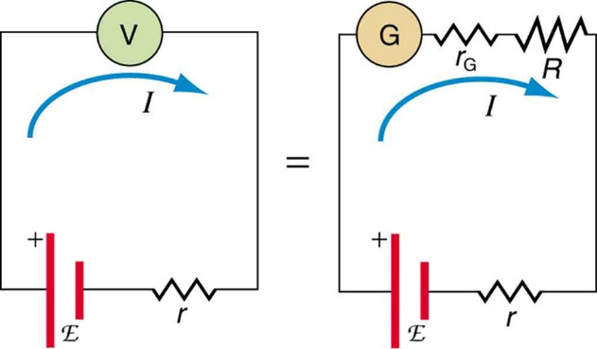
Figure 21.25: An analog voltmeter attached to a battery draws a small but nonzero current and measures a terminal voltage that differs from the emf of the battery. (Note that the script capital E symbolizes electromotive force, or emf.) Since the internal resistance of the battery is not known precisely, it is not possible to calculate the emf precisely.
A potentiometer is a null measurement device for measuring potentials (voltages). (See Figure 21.26.) A voltage source is connected to a resistor R, say, a long wire, and passes a constant current through it. There is a steady drop in potential (an IR drop) along the wire, so that a variable potential can be obtained by making contact at varying locations along the wire.
Figure 21.26 (b) shows an unknown emf_{x} (represented by script E_{x} in the figure) connected in series with a galvanometer. Note that emf_{x} opposes the other voltage source. The location of the contact point (see the arrow on the drawing) is adjusted until the galvanometer reads zero. When the galvanometer reads zero, emf_{x} = IR_{x}, where R_{x} is the resistance of the section of wire up to the contact point. Since no current flows through the galvanometer, none flows through the unknown emf, and so emf_{x} is directly sensed.
Now, a very precisely known standard emfs is substituted for emf_{x}, and the contact point is adjusted until the galvanometer again reads zero, so that emf_{s} =IR_{s}. In both cases, no current passes through the galvanometer, and so the current I through the long wire is the same. Upon taking the ratio emf_{x} / emf_{s}, I cancels, giving
emf_{x} / emf_{s} = IR_{x} / IR_{s} = R_{x}/R_{s}.
Solving for emf_{x} gives
emf_{x} = emf_{s} (R_{x} / R_{s})
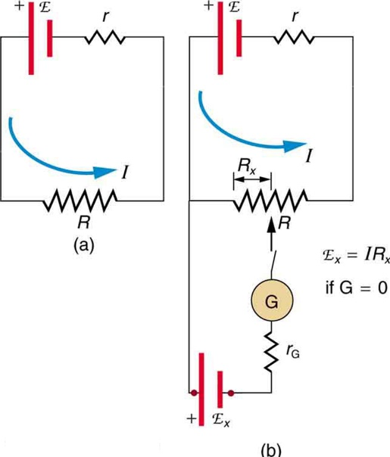
Figure 21.26: The potentiometer, a null measurement device. (a) A voltage source connected to a long wire resistor passes a constant current, I through it. (b) An unknown emf (labeled script Ex in the figure) is connected as shown, and the point of contact along R is adjusted until the galvanometer reads zero. The segment of wire has a resistance R_{x} and script E_{x} = IR_{x}, where I is unaffected by the connection since no current flows through the galvanometer. The unknown emf is thus proportional to the resistance of the wire segment.
Because a long uniform wire is used for R, the ratio of resistances R_{x}/R_{s} is the same as the ratio of the lengths of wire that zero the galvanometer for each emf. The three quantities on the right-hand side of the equation are now known or measured, and emf_{x} can be calculated. The uncertainty in this calculation can be considerably smaller than when using a voltmeter directly, but it is not zero. There is always some uncertainty in the ratio of resistances R_{x}/R_{s} and in the standard emfs. Furthermore, it is not possible to tell when the galvanometer reads exactly zero, which introduces error into both R_{x} and R_{s}, and may also affect the current I.

21.12 Resistance Measurements and the Wheatstone Bridge
There is a variety of so-called ohmmeters that purport to measure resistance. What the most common ohmmeters actually do is to apply a voltage to a resistance, measure the current, and calculate the resistance using Ohm’s law. Their readout is this calculated resistance. Two configurations for ohmmeters using standard voltmeters and ammeters are shown in Figure 21.27. Such configurations are limited in accuracy, because the meters alter both the voltage applied to the resistor and the current that flows through it.
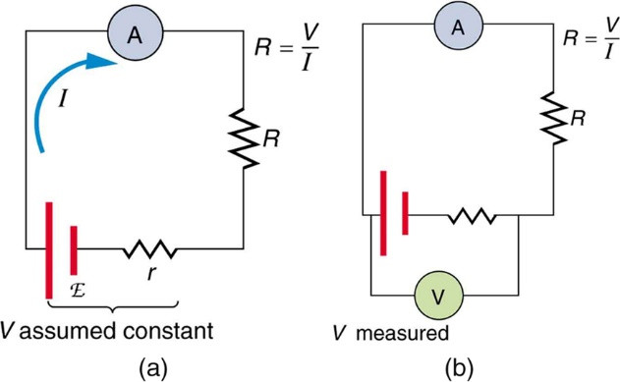
Figure 21.27: Two methods for measuring resistance with standard meters. (a) Assuming a known voltage for the source, an ammeter measures current, and resistance is calculated as R = V/I. (b) Since the terminal voltage V varies with current, it is better to measure it. V is most accurately known when I is small, but I itself is most accurately known when it is large.
The Wheatstone bridge is a null measurement device for calculating resistance by balancing potential drops in a circuit. (See Figure 21.28.) The device is called a bridge because the galvanometer forms a bridge between two branches. A variety of bridge devices are used to make null measurements in circuits.
Resistors R₁ and R₂ are precisely known, while the arrow through R3 indicates that it is a variable resistance. The value of R₃ can be precisely read. With the unknown resistance R_{x} in the circuit, R3 is adjusted until the galvanometer reads zero. The potential difference between points b and d is then zero, meaning that b and d are at the same potential. With no current running through the galvanometer, it has no effect on the rest of the circuit. So, the branches abc and adc are in parallel, and each branch has the full voltage of the source. That is, the IR drops along abc and adc are the same. Since b and d are at the same potential, the IR drop along ad must equal the IR drop along ab. Thus,
I₁R₁ = I₂R₃
Again, since b and d are at the same potential, the IR drop along dc must equal the IR drop along bc. Thus,
I₁R₂ = I₂R_{x}

Taking the ratio of these last two expressions gives
I₁R₁ / I₁R₂ = I₂R₃ / I₂R_{x}

Canceling the currents and solving for R_{x} yields
R_{x} = R₃ (R₂/R₁)
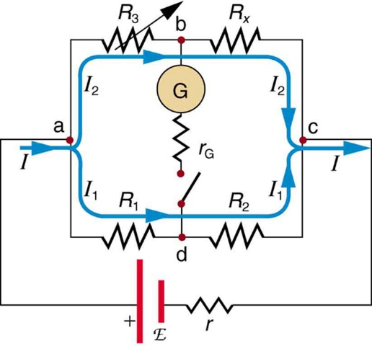
Figure 21.28: The Wheatstone bridge is used to calculate unknown resistances. The variable resistance R3 is adjusted until the galvanometer reads zero with the switch closed. This simplifies the circuit, allowing Rx to be calculated based on the IR drops as discussed in the text.
This equation is used to calculate the unknown resistance when current through the galvanometer is zero. This method can be very accurate (often to four significant digits), but it is limited by two factors. First, it is not possible to get the current through the galvanometer to be exactly zero. Second, there are always uncertainties in R₁, R₂, and R₃, which contribute to the uncertainty in R_{x}.
21.13 RC Circuits
An RC circuit is one containing a resistor R and a capacitor C. The capacitor is an electrical component that stores electric charge.
Figure 21.29 shows a simple RC circuit that employs a DC (direct current) voltage source. The capacitor is initially uncharged. As soon as the switch is closed, current flows to and from the initially uncharged capacitor. As charge increases on the capacitor plates, there is increasing opposition to the flow of charge by the repulsion of like charges on each plate.
In terms of voltage, this is because voltage across the capacitor is given by V_{c} =Q/C, where Q is the amount of charge stored on each plate and C is the capacitance. This voltage opposes the battery, growing from zero to the maximum emf when fully charged. The current thus decreases from its initial value of I₀ = emf / R to zero as the voltage on the capacitor reaches the same value as the emf. When there is no current, there is no IR drop, and so the voltage on the capacitor must then equal the emf of the voltage source. This can also be explained with Kirchhoff’s second rule (the loop rule), discussed in Kirchhoff’s Rules, which says that the algebraic sum of changes in potential around any closed loop must be zero.
The initial current is I₀ = emf / R, because all of the IR drop is in the resistance. Therefore, the smaller the resistance, the faster a given capacitor will be charged. Note that the internal resistance of the voltage source is included in R, as are the resistances of the capacitor and the connecting wires. In the flash camera scenario above, when the batteries powering the camera begin to wear out, their internal resistance rises, reducing the current and lengthening the time it takes to get ready for the next flash.
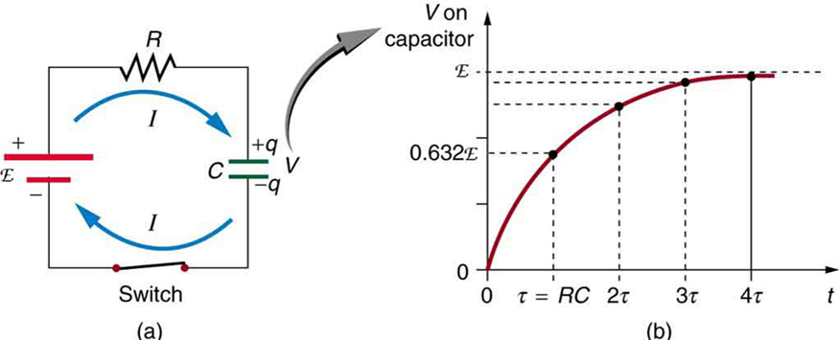
Figure 21.29: (a) An RC circuit with an initially uncharged capacitor. Current flows in the direction shown (opposite of electron flow) as soon as the switch is closed. Mutual repulsion of like charges in the capacitor progressively slows the flow as the capacitor is charged, stopping the current when the capacitor is fully charged and Q = C ⋅ emf. (b) A graph of voltage across the capacitor versus time, with the switch closing at time t=0. (Note that in the two parts of the figure, the capital script E stands for emf, q stands for the charge stored on the capacitor, and τ is the RC time constant.)
Voltage on the capacitor is initially zero and rises rapidly at first, since the initial current is a maximum. Figure 21.29 (b) shows a graph of capacitor voltage versus time (t) starting when the switch is closed at t=0. The voltage approaches emf asymptotically, since the closer it gets to emf the less current flows. The equation for voltage versus time when charging a capacitor C through a resistor R, derived using calculus, is
V = emf(1−e^{−t/RC}) - when charging

where V is the voltage across the capacitor, emf is equal to the emf of the DC voltage source, and the exponential e = 2.718 … is the base of the natural logarithm. Note that the units of RC are seconds. We define,
τ = RC
where τ (the Greek letter tau) is called the time constant for an RC circuit. As noted, before, a small resistance R allows the capacitor to charge faster. This is reasonable, since a larger current flows through a smaller resistance. It is also reasonable that the smaller the capacitor C, the less time needed to charge it. Both factors are contained in τ = RC.
More quantitatively, consider what happens when t = τ = RC. Then the voltage on the capacitor is
V = emf(1−e⁻¹) = emf(1−0.368) = 0.632⋅emf
This means that in the time τ=RC, the voltage rises to 0.632 of its final value. The voltage will rise 0.632 of the remainder in the next time τ. It is a characteristic of the exponential function that the final value is never reached, but 0.632 of the remainder to that value is achieved in every time, τ. In just a few multiples of the time constant τ, then, the final value is very nearly achieved, as the graph in Figure 21.29 (b) illustrates.

Discharging a Capacitor
Discharging a capacitor through a resistor proceeds in a similar fashion, as Figure 21.30 illustrates. Initially, the current is I₀ = V₀ / R, driven by the initial voltage V₀ on the capacitor. As the voltage decreases, the current and hence the rate of discharge decreases, implying another exponential formula for V. Using calculus, the voltage V on a capacitor C being discharged through a resistor R is found to be
V = V₀ e^{−t/RC} – When discharging

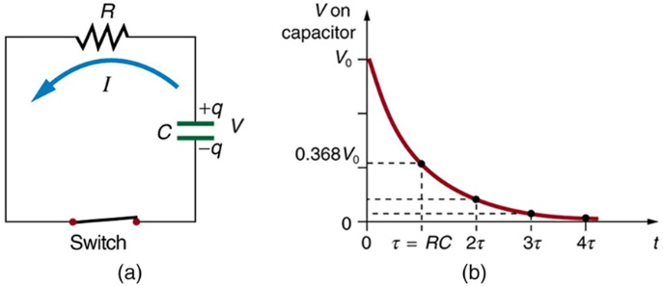
Figure 21.30: (a) Closing the switch discharges the capacitor C through the resistor R. Mutual repulsion of like charges on each plate drives the current. (b) A graph of voltage across the capacitor versus time, with V=V0 at t=0. The voltage decreases exponentially, falling a fixed fraction of the way to zero in each subsequent time constant τ.
The graph in Figure 21.30 (b) is an example of this exponential decay. Again, the time constant is τ=RC. A small resistance R allows the capacitor to discharge in a small time, since the current is larger. Similarly, a small capacitance requires less time to discharge, since less charge is stored. In the first time interval τ=RC after the switch is closed, the voltage falls to 0.368 of its initial value, since V=V₀⋅e⁻¹ = 0.368V0.
During each successive time τ, the voltage falls to 0.368 of its preceding value. In a few multiples of τ, the voltage becomes very close to zero, as indicated by the graph in Figure 21.30 (b).
Now we can explain why the flash camera in our scenario takes so much longer to charge than discharge; the resistance while charging is significantly greater than while discharging. The internal resistance of the battery accounts for most of the resistance while charging. As the battery ages, the increasing internal resistance makes the charging process even slower.

RC Circuits for Timing
RC circuits are commonly used for timing purposes. A mundane example of this is found in the ubiquitous intermittent wiper systems of modern cars. The time between wipes is varied by adjusting the resistance in an RC circuit. Another example of an RC circuit is found in novelty jewelry, Halloween costumes, and various toys that have battery-powered flashing lights. (See Figure 21.31 for a timing circuit.)
A more crucial use of RC circuits for timing purposes is in the artificial pacemaker, used to control heart rate. The heart rate is normally controlled by electrical signals generated by the sino-atrial (SA) node, which is on the wall of the right atrium chamber. This causes the muscles to contract and pump blood. Sometimes the heart rhythm is abnormal and the heartbeat is too high or too low.
The artificial pacemaker is inserted near the heart to provide electrical signals to the heart when needed with the appropriate time constant. Pacemakers have sensors that detect body motion and breathing to increase the heart rate during exercise to meet the body’s increased needs for blood and oxygen.
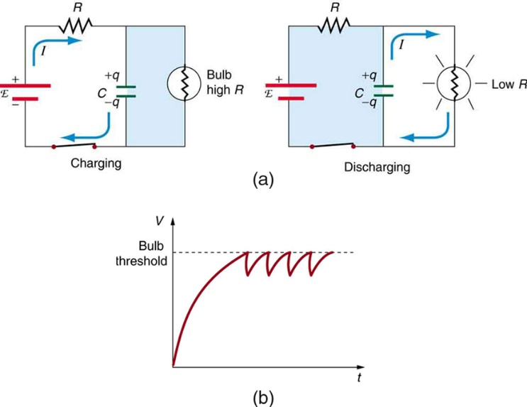
Figure 21.31: (a) The lamp in this RC circuit ordinarily has a very high resistance, so that the battery charges the capacitor as if the lamp were not there. When the voltage reaches a threshold value, a current flows through the lamp that dramatically reduces its resistance, and the capacitor discharges through the lamp as if the battery and charging resistor were not there. Once discharged, the process starts again, with the flash period determined by the RC constant τ. (b) A graph of voltage versus time for this circuit.
For examples and answers, please refer to OpenStax.com questions and answers given on their website or to the College Physics 2e - https://openstax.org/details/books/college-physics-2e

